Leo Nguyen - ldn190002

Amol Perubhatla - AVP180003

**Chatbot-Report and Evaluation**

1. **Introduction**

* Our chatbot is a ruled-base system bot which will provide basic information on cyberpunk genre based on the user’s querry. This is a basic chatbot, so all of our data was collected from <https://www.neondystopia.com/>.
* How to run:
  + Open the command-line
  + Type in py chatbot.py

1. **System Description**

* The chatbot system will require 3 files: chatbot.py, knowledge_base.py, and stopwords.txt
* The stopword.txt will contain extensive English stopword list from kaggle.com
* The chatbot.py create and maintain the user’s interface. It will start by asking the username. If it is a new user the program will create a new user’s profile. If it is an existed user the program will open user profile.
* For the system to be able to provide the basic answers regarding cyberpunk related topic. It will need a knowledge base. This is when the knowledge base become handy. If the knowledge base file “k_base.p” already exists on the the system, it will autoload by the “chatbot.py” if not, the chatbot file will call the “knowledge_base.py” to extract the data from <https://www.neondystopia.com/> and create the “k_base.p” file.
* The chatbot utilize serveal NLP techniques:
  + To collect and create the knowledge base raw data, the sytem use **webcrawling** and **webscraping** techniques. First, it will perform the webcrawling from the stater url <https://www.neondystopia.com/> to extract 10 most relavent urls from the starter url. Then for each relavent url, a raw data will be collected by webcrapping technique.
  + To be able to use the knowledge base, this draw data need to be preprocess to remove unnecessary elements such as extra space and special characters using **regex** technique Then use the **sent_tokenize** technique to break into separate sentences. Finally, save and output this sentences collection into a **pickle** file to be used for the next step. This help to reduce the time for chatbot systems to initialize.
  + After the knowledge base pickle is ready. The system will be intialized with different user mode. Each user will be maintained by name and user profile using **dictionary** techique with username is the key, and 2 values: name and user’s keyword.
  + The system is ready when the user data was created/loaded and the knowledge base file loaded. Each user input will be tokenized by **word_tokenizer** technique then further processing to remove the **stopword** and none alphabet characters. Then the final keyword will be feed into the chatbot respond function to find the most relavant to the querry.
  + To be able to find the relavant answer for the querry, the system utilize 2 main techniques: **TfidfVectorizer** and **cosine_similarity**. The first technique-TfidfVectorizer will convert the corpus of knowledge base into vector of sentences based on their frequency and weighting that frequency in term of the level of impact. Then use the cosine_similariry technique to compare the user input with with sentences vectors to find the most relavant to the keyword.
  + Finally, print the the most relavant answer for the querry. The system will then save this querry into user profile in user dictionary. So it can provide better suggestions when user come back next time.

1. **Diagram of chatbot dialog tree and logic.**

1. **Sample dialog interaction**

* **New user mode:**

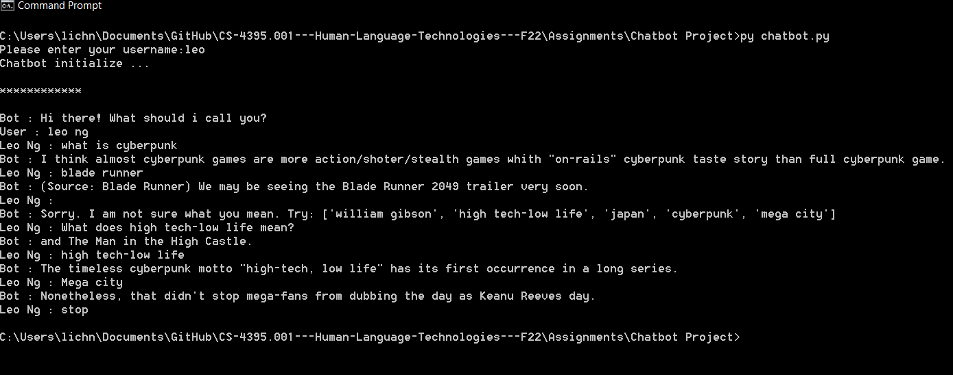

* **Existed user mode:**

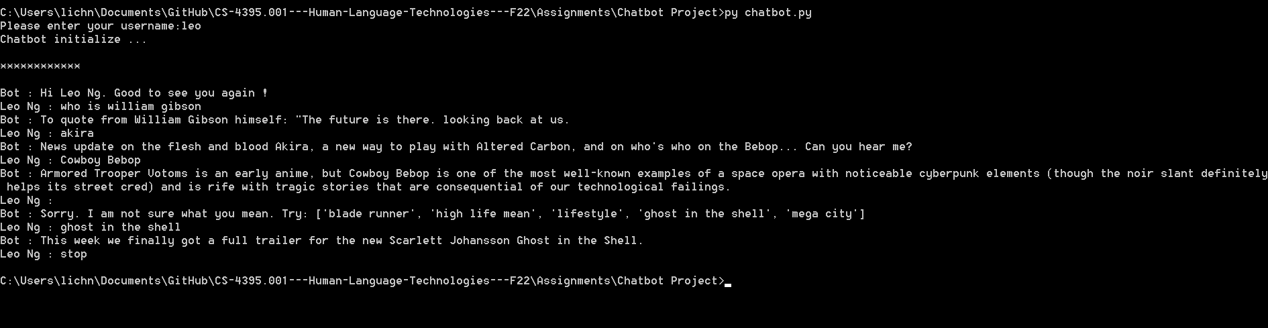

1. **Appendix for Knowledge base**

* Data was mainly collected from <https://www.neondystopia.com/>
* Ten main urls extracted from starter url:
  1. https://www.neondystopia.com/cyberpunk-movies-anime/
  2. https://www.neondystopia.com/cyberpunk-politics-philosophy/
  3. https://www.neondystopia.com/cyberpunk-books-fiction/
  4. https://www.neondystopia.com/cyberpunk-games/
  5. https://www.neondystopia.com/cyberpunk-music/
  6. https://www.neondystopia.com/cyberpunk-technology/
  7. https://www.neondystopia.com/cyberpunk-art-photography/
  8. https://www.neondystopia.com/cyberpunk-fashion-lifestyle/
  9. https://neondystopia.com/cyberpunk-games-database/
  10. <https://www.neondystopia.com/what-is-cyberpunk/>
* Then from each url above, the system will extract 10 more urls and scrape the data from that 10 urls to build the knowledge base

1. **Appendix for user mode**

* Each user will be stored to *dict_username.p* with username as key. Each key contains 2 values: name and user’s profile. The user profile will content a string seperated by underscore _ for each keyword user had been used before.
* User mode with 2 user currently:leo and amol with their name and profile perspectedly

{'leo': ['leo ng', '_cyberpunk_blade runner_high life mean_mega city_william gibson_akira_cowboy bebop_ghost shell'], 'amol': ['amol per', '_matrix_cyberspace_corporation_cyberpunk lifestyle']}

1. **Chatbot Evaluation**

* **Strength:** It is a very simple rule-based chatbot system. If the knowledge base file already exist, it can run by itself without internet or help from other system, API. The system have create and maintain their own files for both knowledge base and user mode file. It can run offline most of the time. The chatbot only require internet to crawling and scraping the starter url to create the knowledge base.
* **Weakness:** Because the system run mainly from the pre collected knowledge base, there is a limited number of answer it provide based on the size of the knowledge base file.